October 7, 2016

Tech mahindra

Automatics user guide

Table of Contents

Pre-Requisite 2

Operating System 2

Software List 2

Installation and Setup 2

JVM Version Check 2

Download JNLP 2

Run Batch 4

AutoMaTics WEBIFY Overview 5

Introduction 5

Login Screen 5

Dashboard - User 5

Dashboard – Admin 6

Create User (User Management) – Admin 6

Create Sub-Application – Admin 7

Create Object Map 7

Create Object Map – Object Map Attributes 8

List Object Map 8

Edit Object Map – Object Map Attributes 9

List Test Case 11

Edit/View Test Case 12

Create Test Suite 13

List/Edit Test Suite 14

Configuration 15

Operation Mapping 16

Known Issues 16

WEBIFY 16

Framework 16

# Pre-Requisite

## Operating System

|  |  |
| --- | --- |
| OS | Yes/No |
| 64 Bit | Yes |
| 32 Bit | No |

## ***Note: Selenium 3.0 Beta4 version does not support 32 bit Windows***

## Software List

|  |
| --- |
| Java Version :1.8+ |
| Firefox Version : 48+ |
| Chrome Version : 52+ |
| IE Version : 11+ |

Note :

For IE do the following settings before executing any test case:

1. Go to settings and then internet options.
2. Select Security in which three options Internet, Local Internet and Trusted Sites are present. Go to these options and check the Enable Protected Mode checkbox.
3. Go to Advanced in which Security option is present. Check the Checkbox as following:

# Installation and Setup

For execution user should have desktop client of AutoMaTics on his system:

## JVM Version Check

Check JVM version on your machine. Open cmd and type following command:

**java -d64 –version**

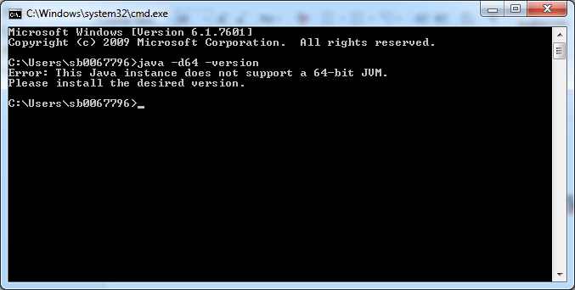

***Note: If it's not a 64-bit version, you'll get a message that looks like:” This Java instance does not support a 64-bit JVM. Please install the desired version.”***

ExecutionThrough Web

For execution of Automatics, user should login through <http://10.13.67.174/AutoMaTics>.

Note**:** User can not Generate/Run Test Suites from web.

## Download JNLP

Download AutoMaticsJar.jnlp from location:

For 32 bit JVM: <http://10.13.67.174:8080/AutoMatics_DTClient/automaticsJar.jnlp>

For 64 bit JVM: <http://10.13.67.174:8080/AutoMatics_DTClient_x64/automaticsJar.jnlp>

1. Open Desktop client : There are two ways to open Desktop client
   1. Double click on “AutoMaticsJar.jnlp”.

OR

From command prompt: type javaws <jnlp location> AutoMaticsJar.jnlp

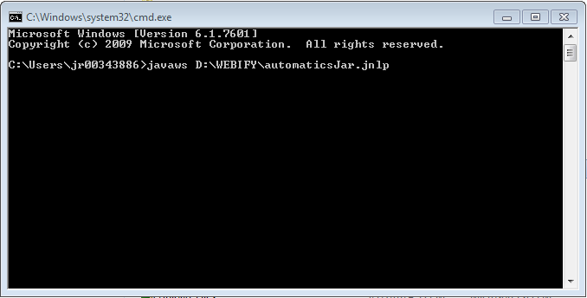

* 1. Accept terms and click Run button

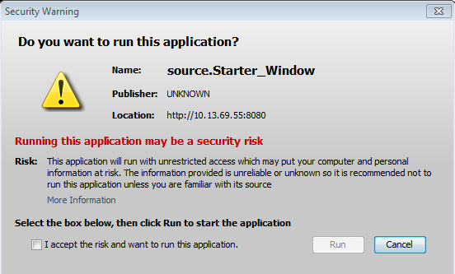

1. Expand right panel from “<<” available on top right

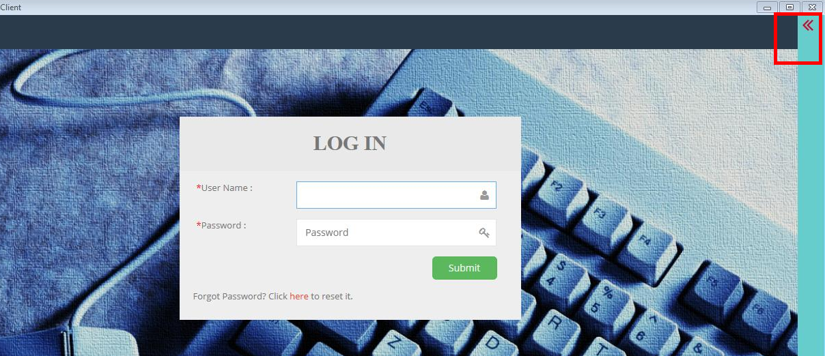

1. Click “Get Package”

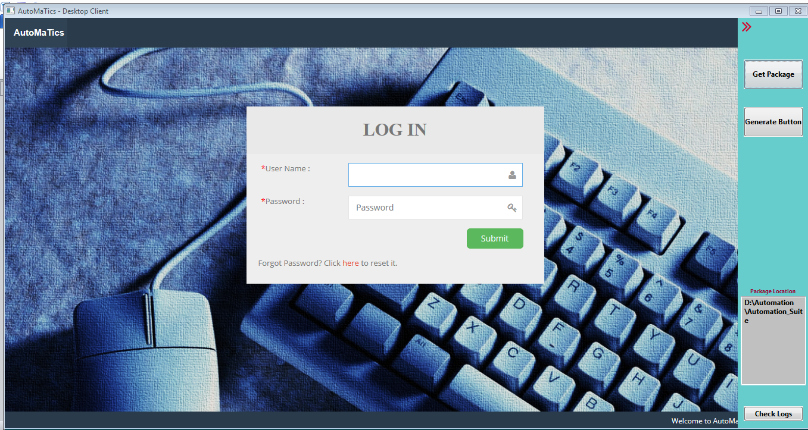

1. Package gets created at the path specified in **Package location**
2. Open eclipse and import the downloaded package.

## Run Batch

1. Launch the WEBIFY and Login with valid credentials
2. Select the Configuration menu
3. Set the Firefox Path and save the settings
4. Generate/Run the Test Suites by clicking on the (Test Suite > List Test Suite) button from the side bar then go to Test Suite Attributes on clicking on the Test Suite. Select the Test Cases which you want to generate or run and then click on the (Generate/Run Suite) button from the side bar(on clicking on the >>).
5. Select the project which was imported in eclipse and refresh the project
6. Click on testng.xml
7. Click on Run button

## Adding Security Exception

Once you download client from following location and run it for the first time, you will get following error message.

For 32 bit JVM: <http://10.13.67.174:8080/AutoMatics_DTClient/automaticsJar.jnlp>

For 64 bit JVM: <http://10.13.67.174:8080/AutoMatics_DTClient_x64/automaticsJar.jnlp>

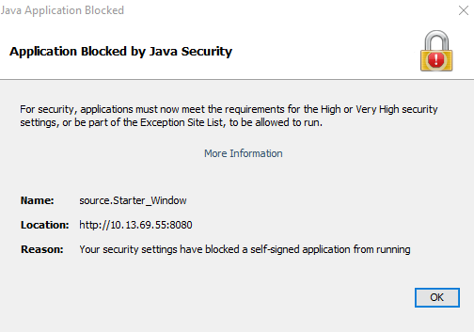

To resolve this issue follow below steps.

1. Open command line prompt.
2. Navigate to <Java_Installation>\bin directory. Like C:\Program Files (x86)\Java\jre1.8.0_101\bin
3. Execute command javacpl.cpl

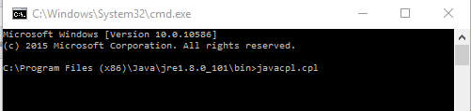

1. This will open Java Console Panel as below

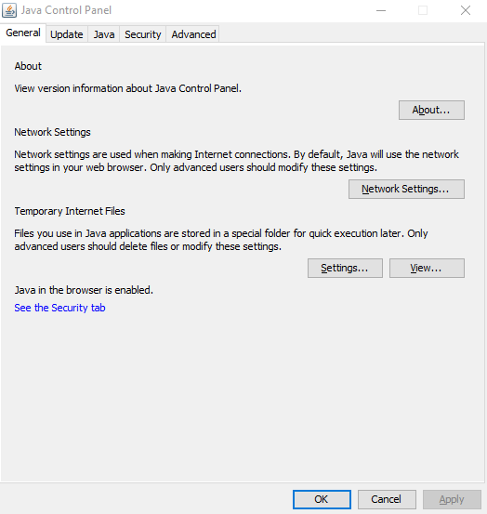

1. Click on Security tab

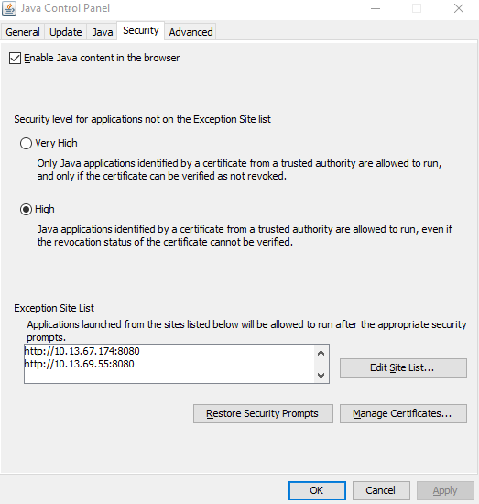

1. Click on Edit Site List button

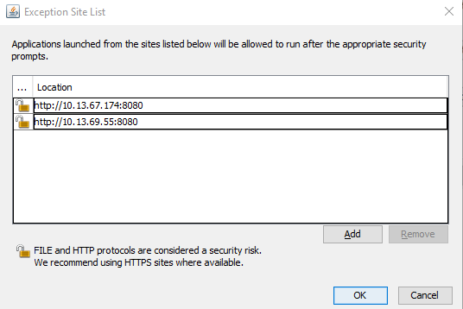

1. Click on Add button

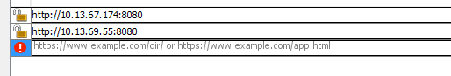

1. Add URL <http://10.13.67.174:8080> and click on Add button
2. You will get a security warning window like below. Click on Continue

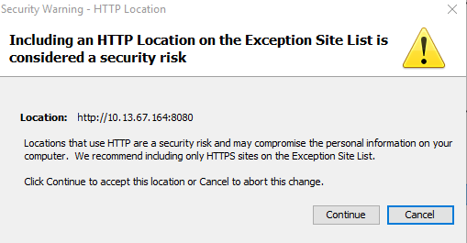

1. Click on Ok on Exception Site List window
2. Now again try to run desktop client
3. You will get a window as below



1. Accept terms and click Run button
2. You should get login window like below



# AutoMaTics WEBIFY Overview

Introduction –

AutoMaTics allows the user to login with following user types –

* USER
* ADMIN

ADMIN has the access to create or update user and assign their privileges according to the selected application. Also Admin can view team progress on Dashboard.

Login Screen

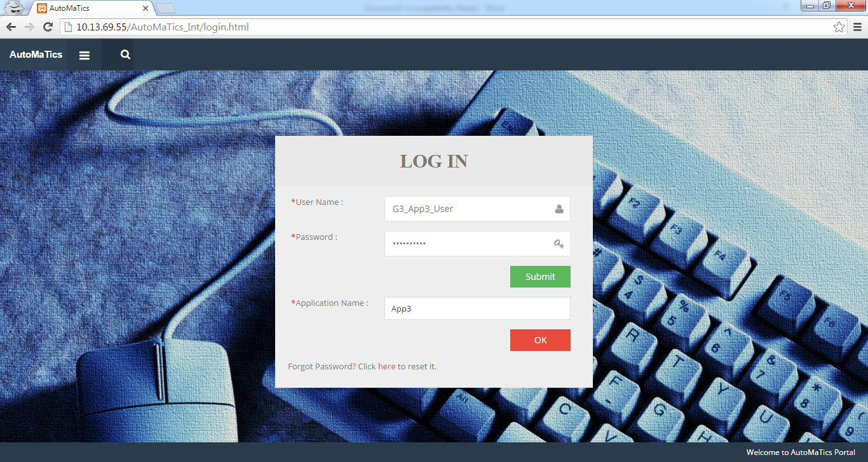

* Enter **User Name** and **Password**
* Click on “**Submit**”
* List of applications are displayed. User can select multiple applications
* After selecting application, click on “**OK**” button

Dashboard - User

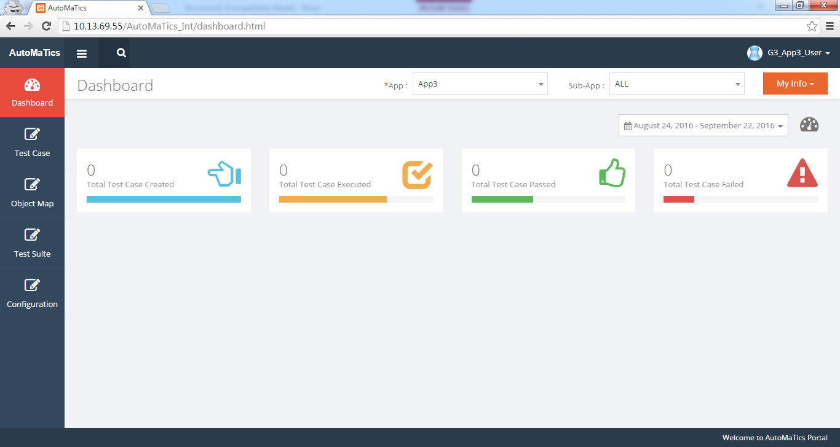

* After Login, Dashboard is displayed to the user
* Provides information about the total test case created, executed, passed and failed by the user

## Dashboard – Admin

* After Login, Dashboard is displayed to the ADMIN
* If **My Info** is selected from the menu present in right hand side. It provides information about the total test case created, executed, passed and failed by the admin
* If **Team Info** is selected then provides the test case information about the team
* **ADMIN** menu is available to create new **User** and **Sub-Application**

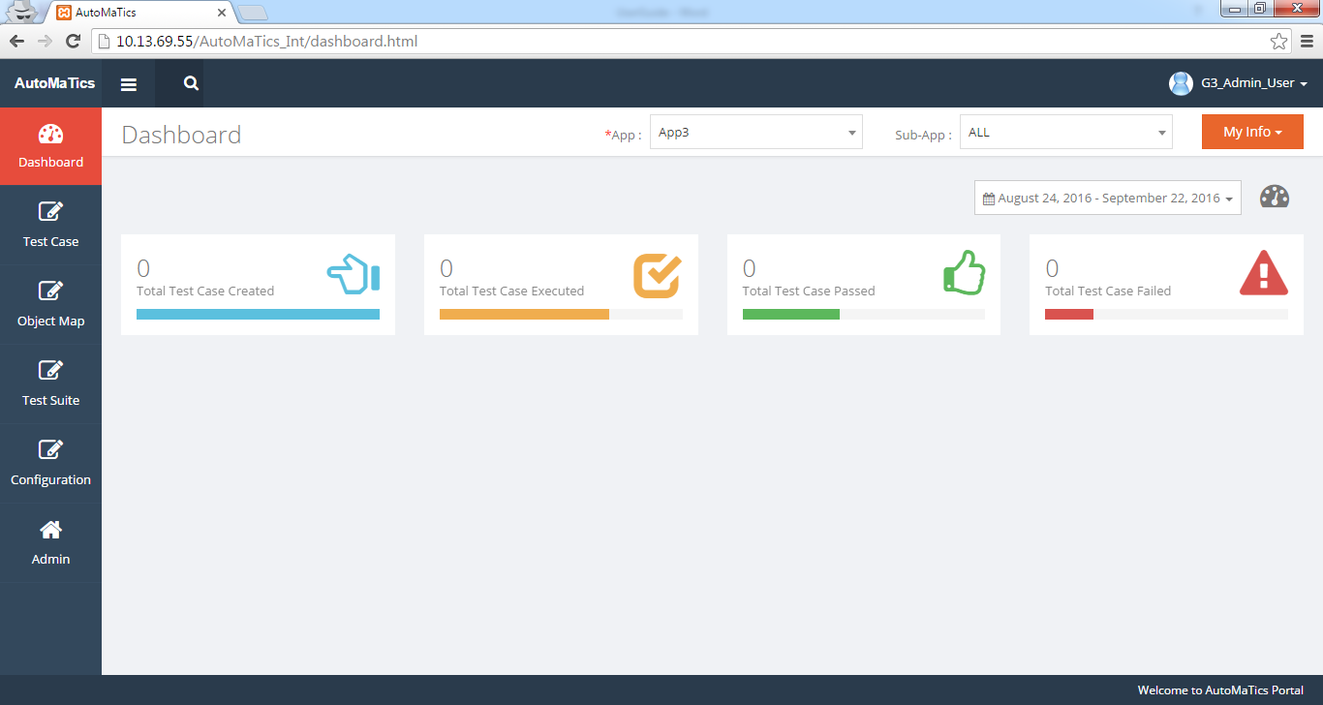

## Create User (User Management) – Admin

* Click on “**Admin”** and then “**User Management**” menu
* Allows to create new user for the selected application. Click on “**+**” to create new user
* Allows to give privileges to the user like Create, Read, Update and Delete.
* Admincan check/ uncheck the checkboxes to modify the privileges except Read
* Allows to remove the user from the application

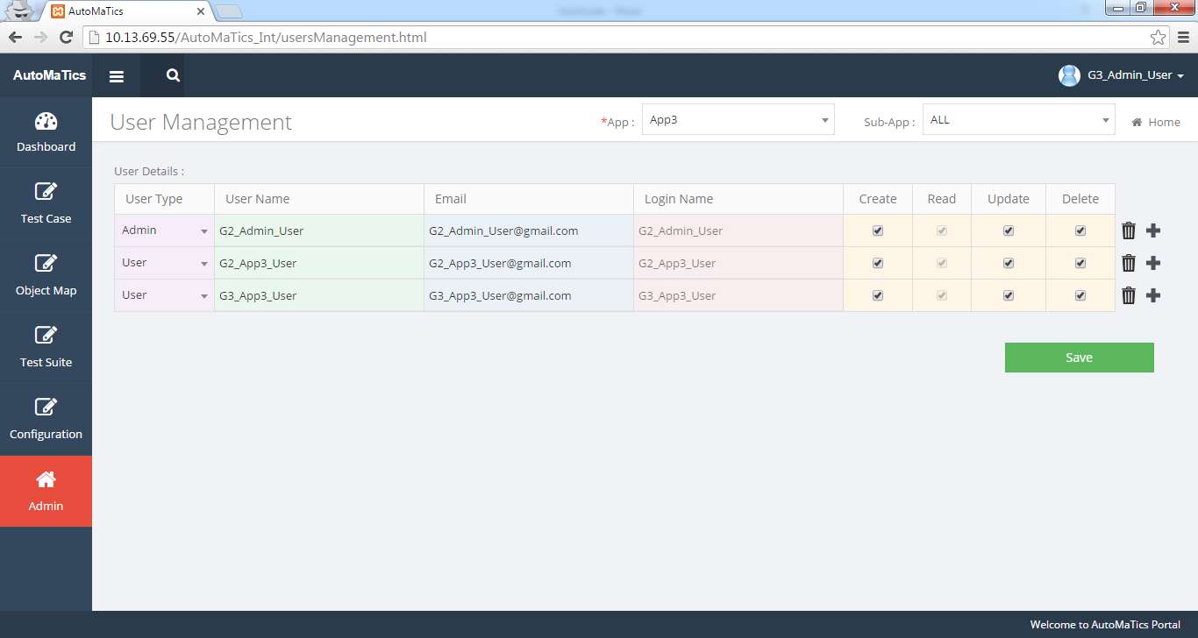

## Create Sub-Application – Admin

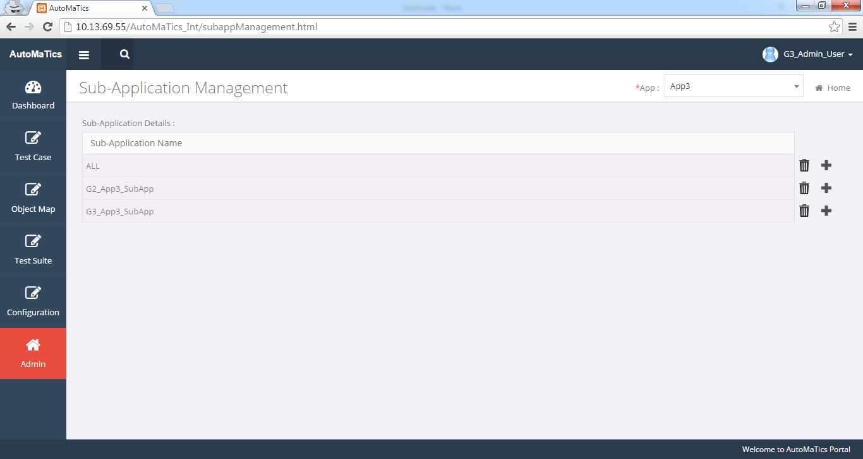

* Click on “**Admin”** and then “**Sub-Application Management**” menu
* Allows to create new sub application by clicking on “+” icon.
* Allows to delete sub application

## Create Object Map

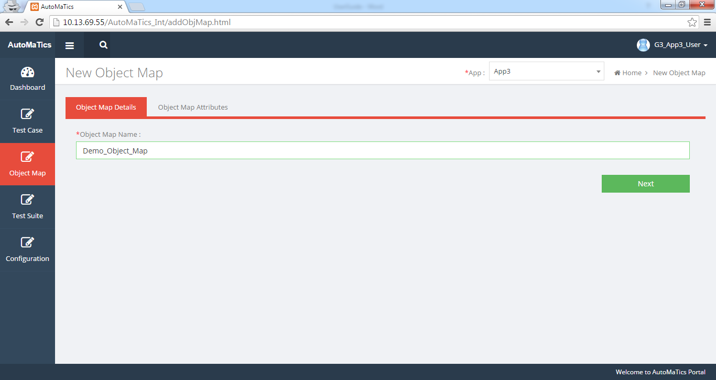

* Click on “**Object Map”** and then “**Create Object Map”** menu
* Enter Object Map name
* Click on “**Next**” button to enter Object Map attributes

## Create Object Map – Object Map Attributes

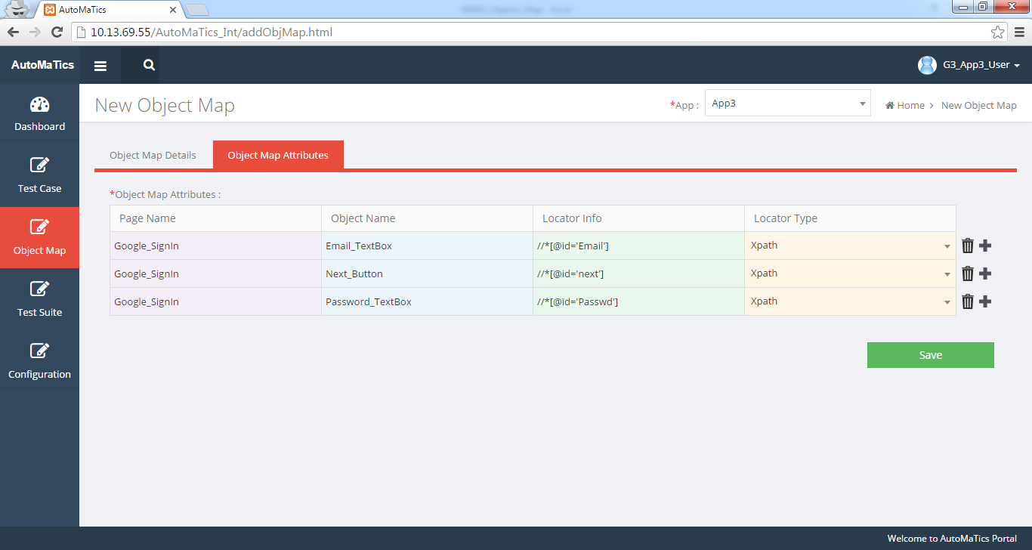

* Click on “**+**” to enter the object map attributes
* Enter all required details like Page Name, Object Name, Locator Info and Locator Type
* Click on “**Save**” button to save the Object Map
* Allows to delete a particular step

## List Object Map

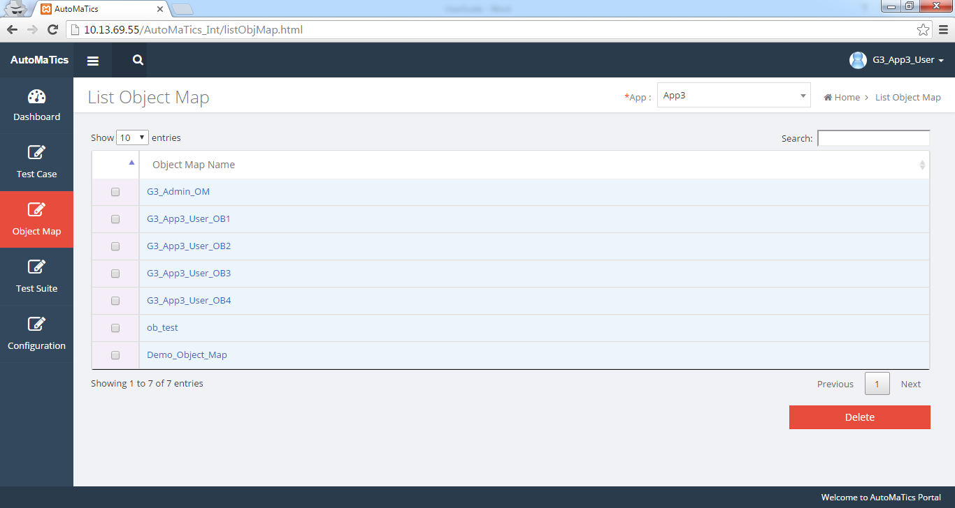

* Click on “**Object Map**” and then “**List Object Map**” menu
* List all the existing object map for the selected application
* Select to view/edit the object map attributes
* Click on “**Delete”** button to delete the single or multiple objects maps. Check the corresponding checkbox and then click on Delete button

## Edit Object Map – Object Map Attributes

* After selecting the Object map from List Object Map, Navigate to Object Map Attributes
* Allows to create copy of existing object map by clicking on “**Save** **As**” button. After Save as provide new name for the object map
* Allow to add more attributes by clicking on “+” icon
* Allows to update existing attribute
* Allows to delete object map attribute
* Allows to delete particular object by clicking on “**Delete”** button
* Allows to reset the attributes by clicking on “**Reset**” button.

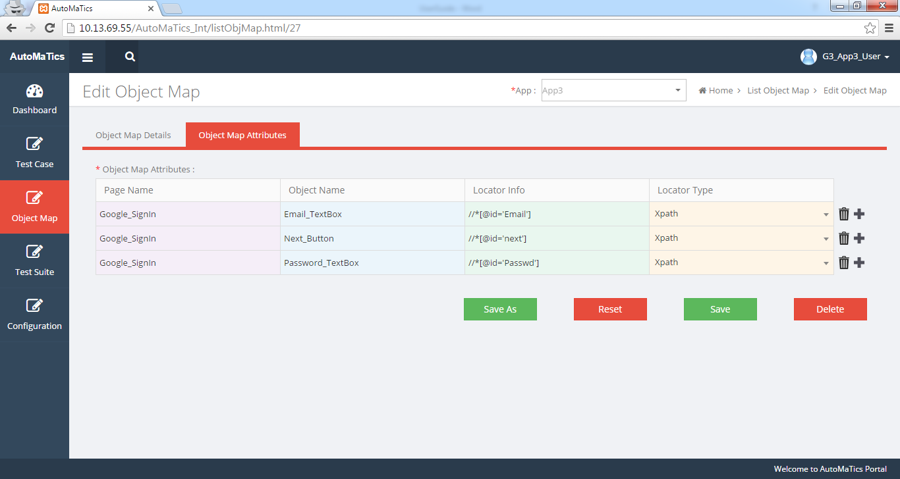

**Create Test Case**

User can create a new Test Case by clicking on the (Test Case > Create Test Case) button from the side bar

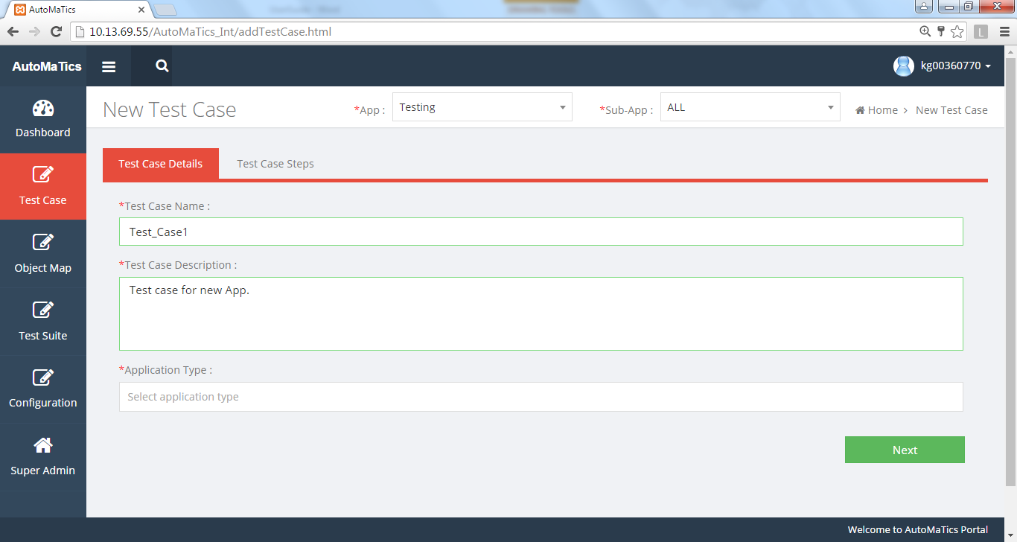

**Tab1 (Test Case Details)**

* Enter Test Case name without any spaces and special symbols.
* Enter Test Case Description
* Select Application Type from the two options: Web/Non-Web, Click “**Next”**.

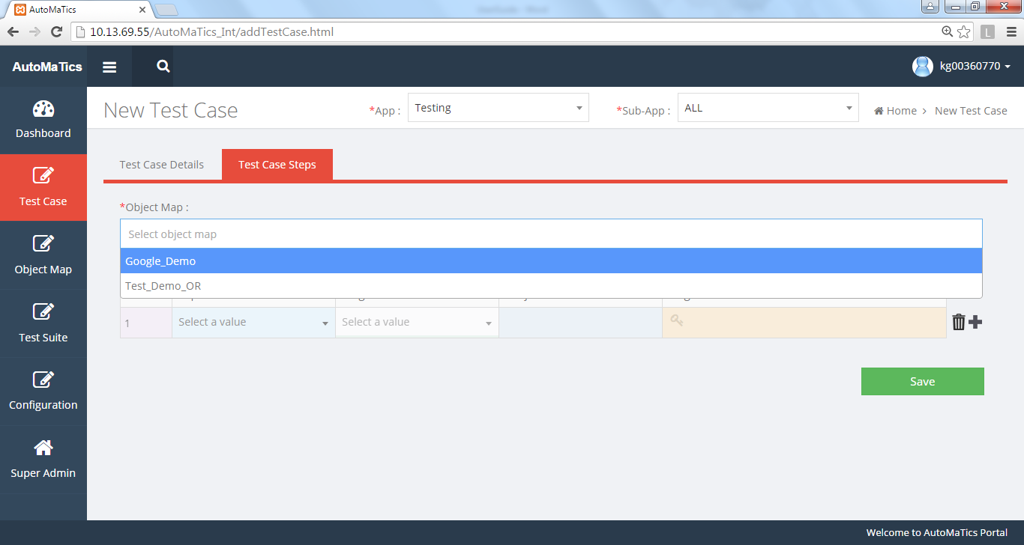

**Tab2 (Test Case Steps)**

**STEP1**

* Select Object Map. User can select multiple object maps if required.

.

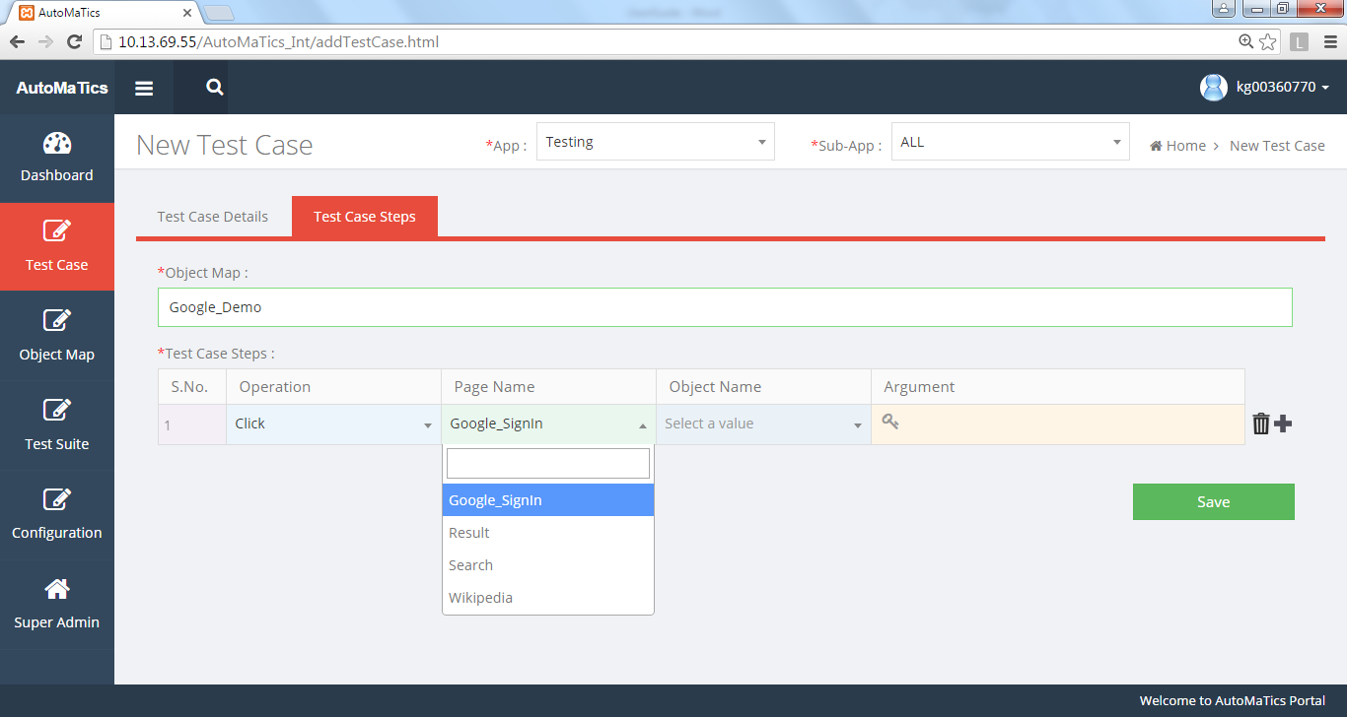

**Tab2 (Test Case Steps)**

**STEP2**

* Select Operation from the drop down list.
* Select Page name and Object Name.
* Enter Argument if required.

.

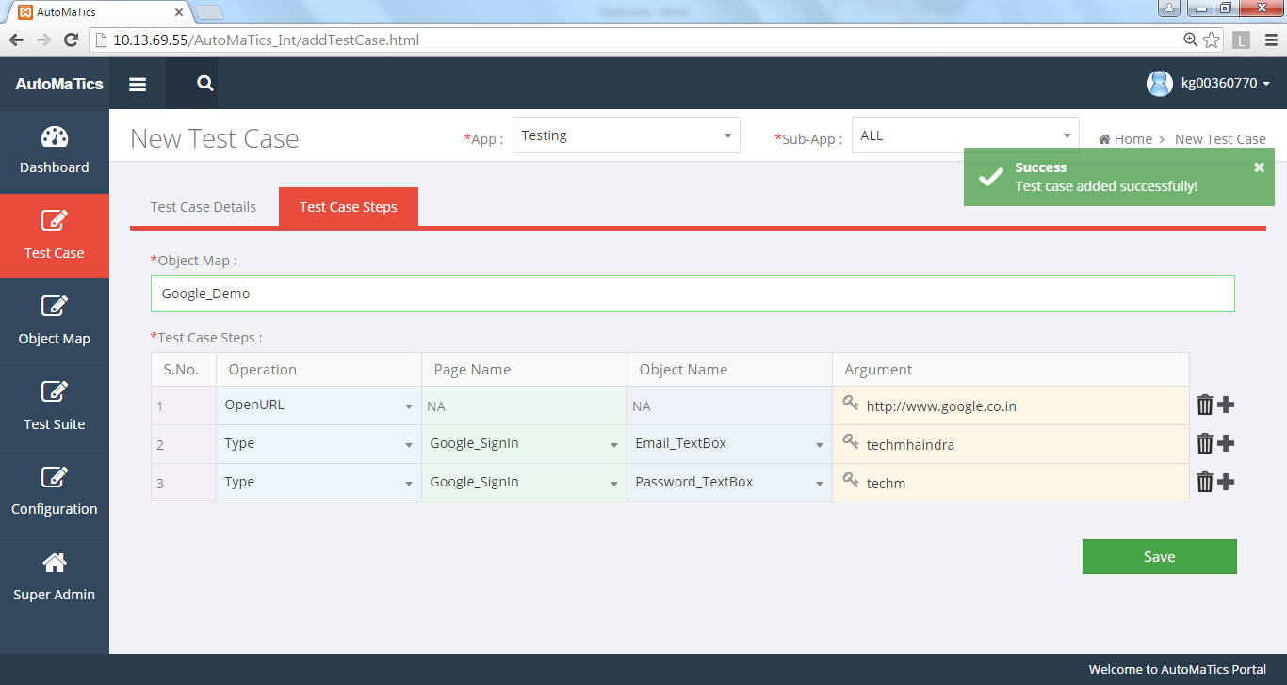

**Tab2 (Test Case Steps)**

**STEP3**

* Click on “**+**” icon to add new step. Click on “**Delete**” Icon to delete any row.
* Click on “**Save”** Button after adding all the steps.

.

## List Test Case

User can see the list of Test Cases by clicking on the (Test Case > List Test Case) button from the side bar –

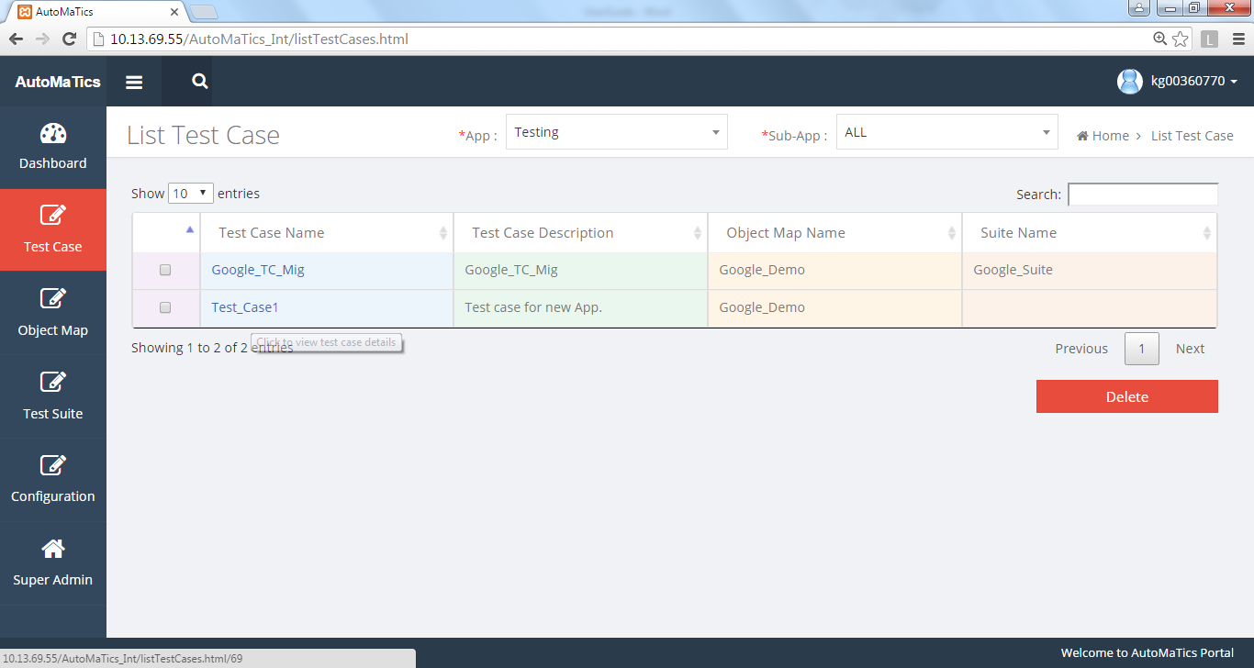

* Test Case created are listed on the List Test Case Page.
* User can view/edit a test case by clicking on its name.
* User can delete the Test Case by Selecting the Checkbox and Clicking on “**Delete”** button.

## Edit/View Test Case

User can Edit or View the Test Case by clicking on the Test Case name from the List Test Case Page as mentioned above.

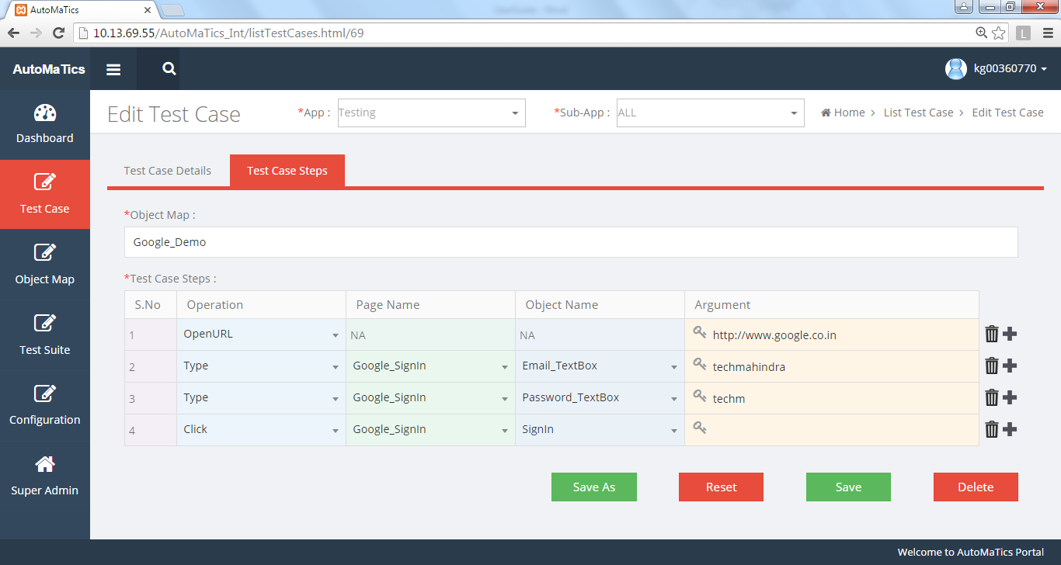

* User can edit Test case Name, Description, Application Type, steps.
* User can add or delete new steps as and when required. Click on “**Save**” after editing.
* User can “**SaveAs**” a Test Case with other name.

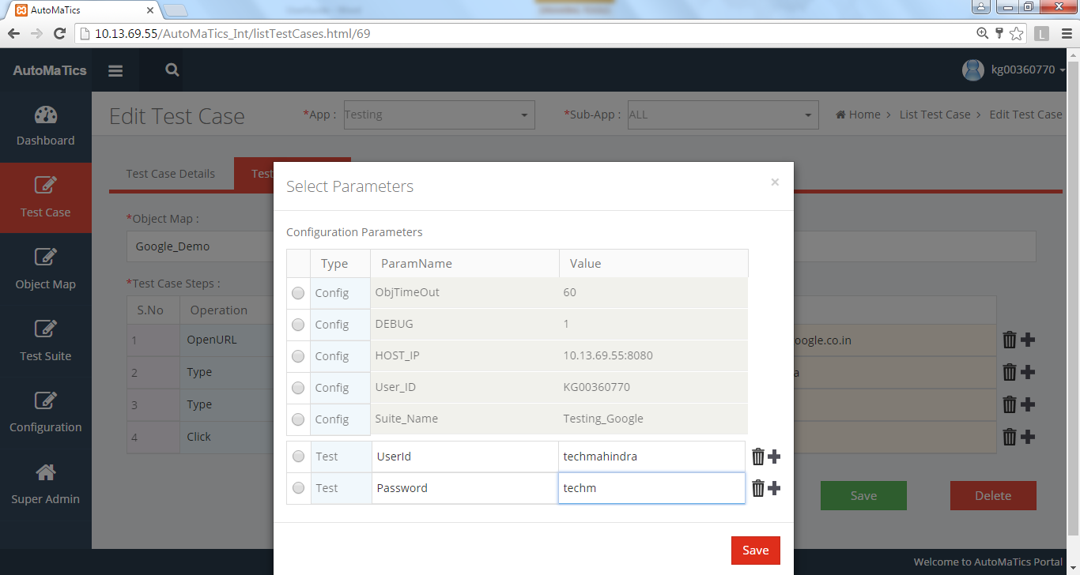

**Edit Test Case- Add Test parameters**

* User can add Test Parameters by clicking on the Key icon in the Argument Text Box.

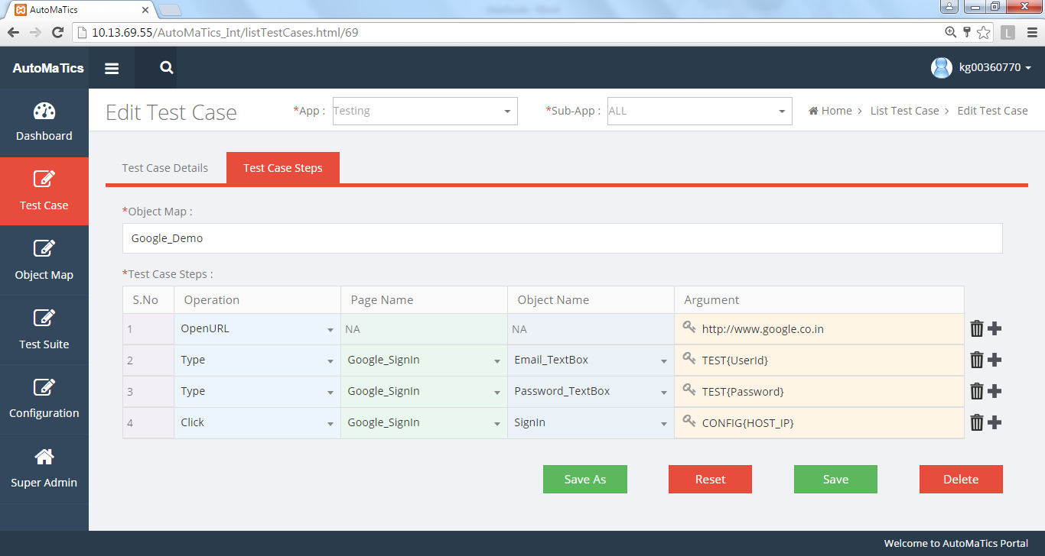

**Edit Test Case- Select Test/ Configuration parameters as Argument**

* Click on the Key icon of the Argument Text Box. A pop-up window as shown above will appear.
* Click on the radio button of the Parameter you want to add.

## Create Test Suite

User Can Create a new Test Suite by clicking on the (Test Suite > Create Test Suite) button from the side bar –

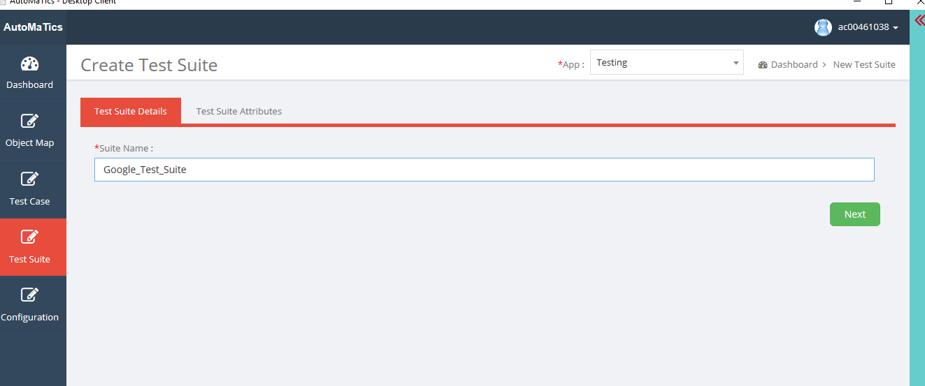

**Step1**

* Enter Test Suite Name without any spaces and special symbols
* Click on “**Next”** or directly click on Test Suite Attributes Tab.

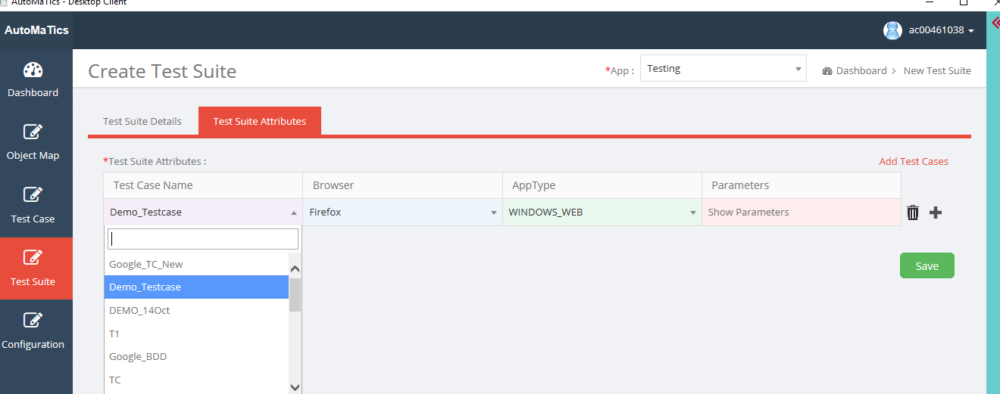

**Step2**

* Test Case Name: Select Test Case to be added to Test Suite.
* Browser: If user wants to run the script on Windows, select browser Type. If user wants to run the script on mobile type Device ID.
* AppType: Select the application type under test.
* Parameters: To see the list of Parameters added.
* User can add multiple Test cases to run in a batch by clicking on the “**+**” icon.
* Click on “**Save**” button.

## List/Edit Test Suite

User can see the list of Test Suites by clicking on the (Test Suite > List Test Suite) button from the side bar –

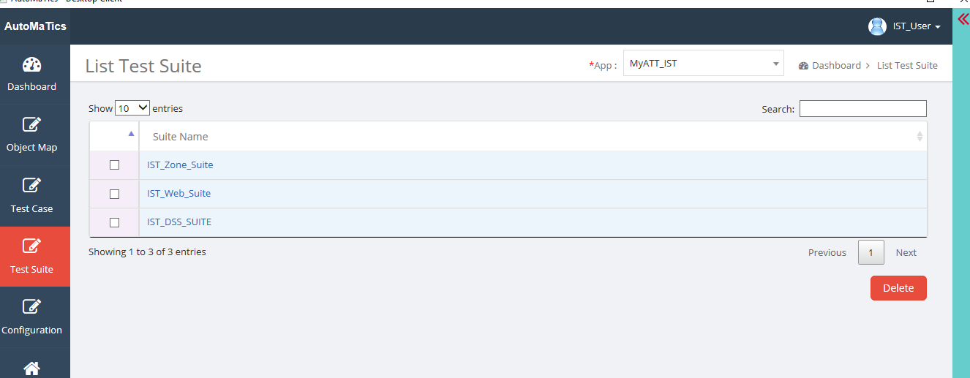

* Select the Test Suite to be edited.
* Click on “**Next/Test suite Attributes**” Tab.

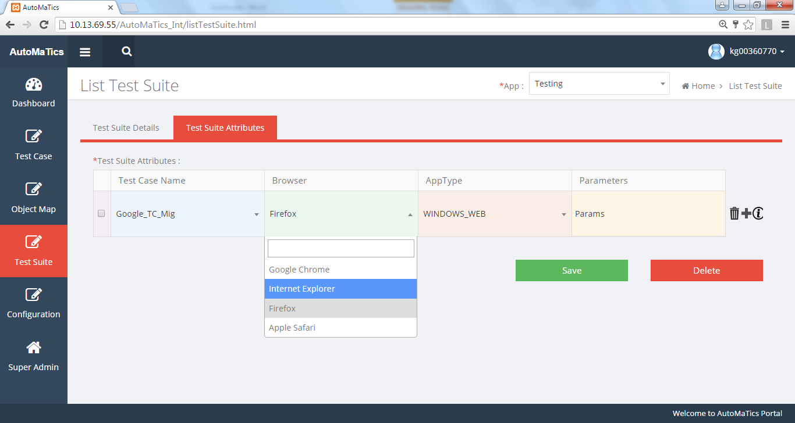

* User can do the changes if required.
* Clicking on the “**i**” icon will show the Test case Details.
* After Changes, Click on “**Save**” button.

## Configuration

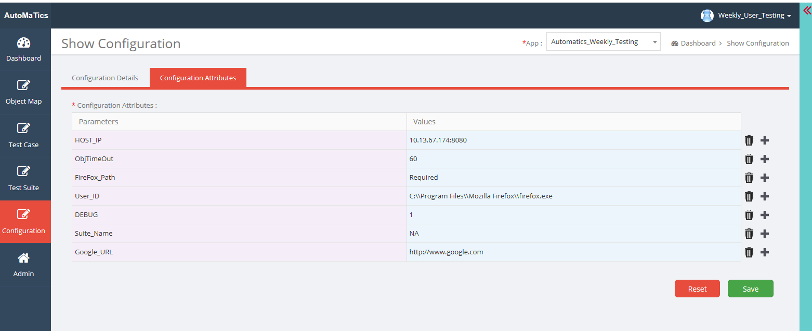

* Set Configuration parameters

# Operation Mapping

Change the existing operation name and mapped it with new operation. Below is the mapping sheet -



# Known Issues

## WEBIFY



## Framework

|  |  |
| --- | --- |
| **Methods** | **Description** |
| OpenIn_NewWindow | Actions Class not implemented in beta4,Allow Popup needs to be handled |
| Focus | Actions Class not implemented in beta4 |
| KeyPress | Actions Class not implemented in beta4 |
| DoubleClick | Actions Class not implemented in beta4 |
| AcceptAlert | Works with selenium 53 |
| CancelAlert | Works with selenium 53 |
| Close | Works with selenium 53 |
| MouseClick | Actions Class not implemented in beta4 |
| MouseOver | Actions Class not implemented in beta4 |